**BUNGEE CODING**

**1]YEAR:**

import pandas as pd import numpy as np p=pd.read_csv("<https://github.com/Bungeetech/internship-test2/blob/master/input/question-1/main.csv>")

for year in p: if p.year%10==0: print(p.year)

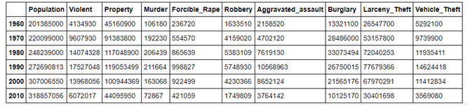

**2]MINMAXAGE:**

import pandas as pd

df=pd.read_csv("https://raw.githubusercontent.com/Bungeetech/internship-test2/master/input/question-2/main.csv")

result = df.groupby('occupation').agg({'age': ['min', 'max']})

print(result)

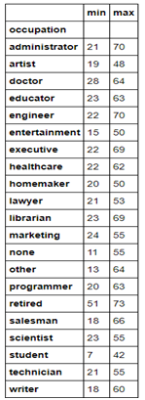

**3]CARDS:**

import pandas as pd

df=pd.read_csv("https://raw.githubusercontent.com/Bungeetech/internship-test2/master/input/question-3/main.csv")

discipline = df[['Team', 'Yellow Cards', 'Red Cards']]

print(discipline)

discipline.sort_values(by=['Red Cards','Yellow Cards'],ascending=False)

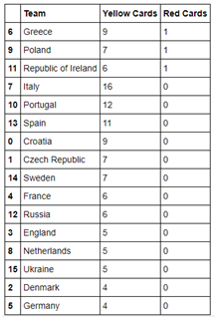

4] Rating - 7/10

Do you want another assessment which more focused on Data structures and algorithms?

YES.